Form 59
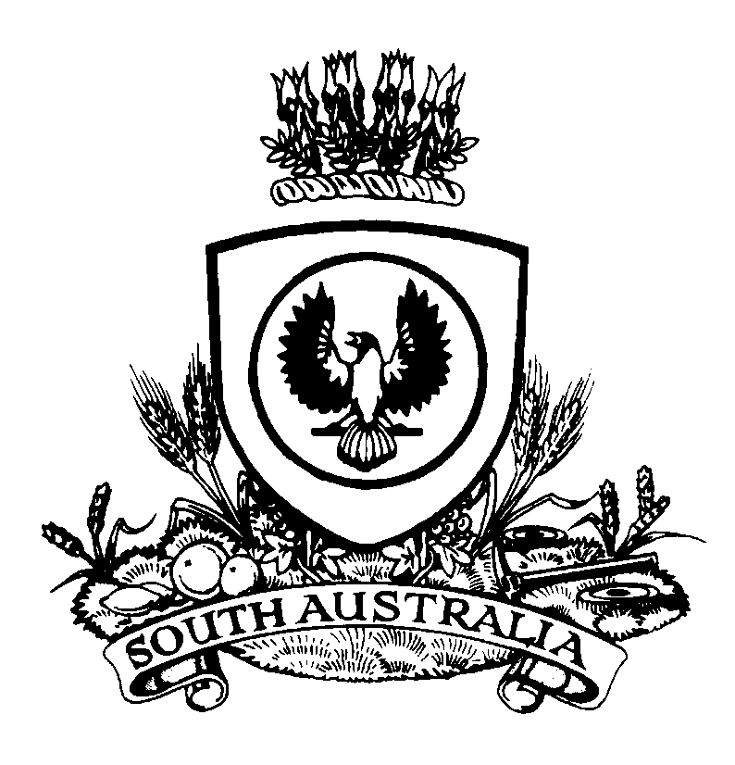 |  |  | ORDER TO EXCLUDE PROPERTY FROM SALE OR DIRECT PROCEEDS OF SALE  Magistrates Court of South Australia  www.courts.sa.gov.au  Fines Enforcement and Debt Recovery Act 2017  Section 36(15) |  |  |  |  |  |  |  |  |  |  |  |  | Court Use  Date Filed:
Registry |  |  |  |  |  |  |  |  |  |  |  | File No
Address
 | Street |  |  |  |  |  |  |  | Telephone |  |  |  |  |  | Facsimile |  |  | DX
 | City/Town/Suburb |  |  |  | State |  | Postcode |  |  | Email Address
Applicant
Full Name |  |  |  |  |  |  |  |  |  |  |  |  |  |  |  |  | DOB
Address
 |  | Street |  |  |  |  |  |  |  |  | Telephone |  |  |  |  |  | Facsimile
 |  | City/Town/Suburb |  |  |  | State |  | Postcode |  |  |  |  | Email Address
Details of the Order
The application has been refused.
I exclude the following property from sale by the Chief Recovery Officer:
1.
2.
3.
4.
5.
I direct that the proceeds from each item identified below be distributed in the manner specified.
Item |  |  |  | Manner of Distribution
Date of Order:
Date MAGISTRATE / REGISTRAR / JUSTICE OF THE PEACE

